**Android Data Storage:-**

It stores application’s data in databases, files, or preferences, in internal or removable storage.

**Android Data Storage Options:-**

Android provides several options for us to save persistent application data. The option we choose depends on our application specific needs, such as whether the data should be private to our application or accessible to other applications (and the user) and how much space our application’s data requires.

Our data storage options are the following:

[Shared Preferences](http://developer.android.com/guide/topics/data/data-storage.html#pref)

Store private primitive data in key-value pairs.

[Internal Storage](http://developer.android.com/guide/topics/data/data-storage.html#filesInternal)

Store private data on the device memory.

[External Storage](http://developer.android.com/guide/topics/data/data-storage.html#filesExternal)

Store public data on the shared external storage.

[SQLite Databases](http://developer.android.com/guide/topics/data/data-storage.html#db)

Store structured data in a private database.

**Note:-** Android provides a way for our application to expose even its private data to other applications — with the help of [content provider](http://developer.android.com/guide/topics/providers/content-providers.html).

Note:- we also can store data on the web (cloud) with our own network server.

**Using Shared Preferences**

The [SharedPreferences](http://developer.android.com/reference/android/content/SharedPreferences.html) class provides a simple mechanism that allows us to save and retrieve private persistent key-value pairs of primitive data types. We can use [SharedPreferences](http://developer.android.com/reference/android/content/SharedPreferences.html) to save any primitive data: booleans, floats, ints, longs, and strings. This data will persist across user sessions (even if your application is killed).

An object of SharedPreferences class is represented by an XML file which stores data in key-value pairs. We don’t need to worry about creation of XML file because its creation automatically done by System. We just put data in it and get data from it, that all we need to do with SharedPreferences.

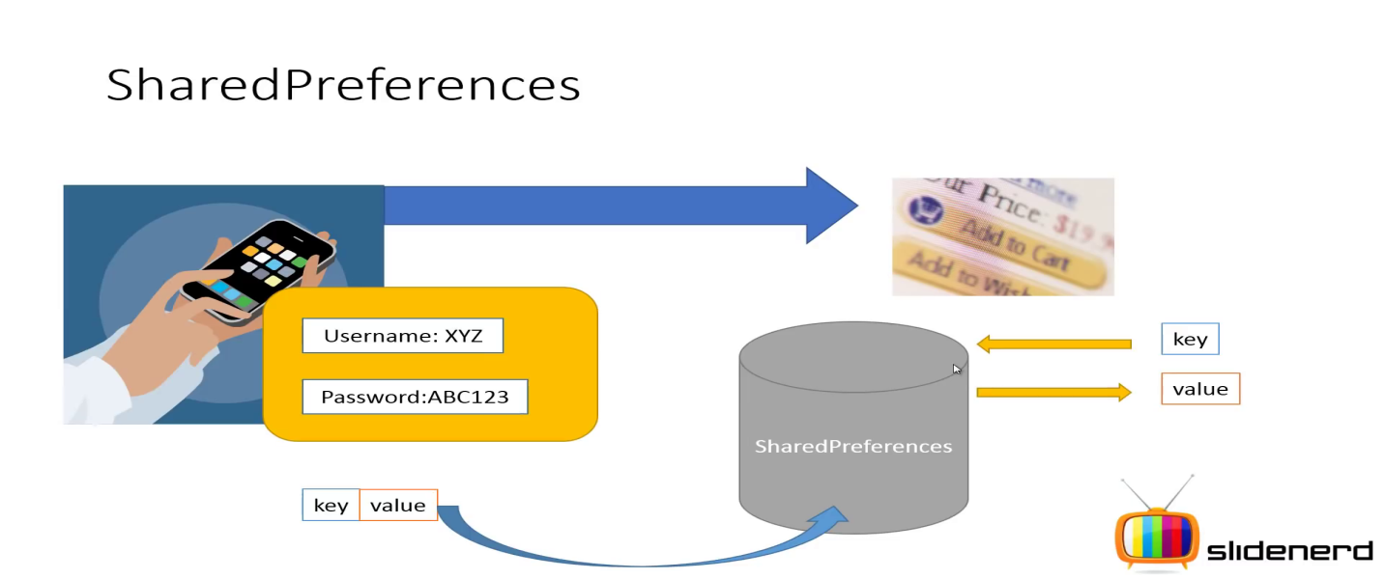

**How to get** [**SharedPreferences**](http://developer.android.com/reference/android/content/SharedPreferences.html) **Object** :-

To get a [SharedPreferences](http://developer.android.com/reference/android/content/SharedPreferences.html) object for our application, use one of two methods:

* [**getSharedPreferences(String name, int mode)**](http://developer.android.com/reference/android/content/Context.html#getSharedPreferences(java.lang.String, int))- Use this if you need multiple preferences files(XML files) identified by name, which you specify with the first parameter.
* [**getPreferences(int mode)**](http://developer.android.com/reference/android/app/Activity.html#getPreferences(int))- Use this if we need only one preferences file for our Activity. Because this will be the only preferences file for our Activity, we don't supply a name.

NOTE- This method returns only that SharedPreferences XML file which name must be as App package name.

**Q:-What is int mode ?**

**A:-**These are static int type constant of Context class. They can be-

1. [MODE_PRIVATE](http://developer.android.com/reference/android/content/Context.html#MODE_PRIVATE)-the default mode, where the created file can only be accessed by the calling application.
2. [MODE_WORLD_READABLE](http://developer.android.com/reference/android/content/Context.html#MODE_WORLD_READABLE)-**This constant was deprecated in API level 17.**
3. [MODE_WORLD_WRITEABLE](http://developer.android.com/reference/android/content/Context.html#MODE_WORLD_WRITEABLE)- **This constant was deprecated in API level 17.**
4. MODE_MULTI_PROCESS- multiple processes can modify the same SharedPreferences.

**How to use SharedPreferences** :-

We can use SharedPreferences –

**To Write/Store values :-**

1. Get reference to SharedPreferences object.
2. Call [edit()](http://developer.android.com/reference/android/content/SharedPreferences.html#edit()) to get a [SharedPreferences.Editor](http://developer.android.com/reference/android/content/SharedPreferences.Editor.html) object.
3. Add values with methods such as [putBoolean()](http://developer.android.com/reference/android/content/SharedPreferences.Editor.html#putBoolean(java.lang.String, boolean)) and [putString()](http://developer.android.com/reference/android/content/SharedPreferences.Editor.html#putString(java.lang.String, java.lang.String))
4. Commit the new values with [commit()](http://developer.android.com/reference/android/content/SharedPreferences.Editor.html#commit()) / apply() of [SharedPreferences.Editor](http://developer.android.com/reference/android/content/SharedPreferences.Editor.html) class.

Commit() – provides synchronous call where as

Apply()-provides Asynchronous call

**How to find where does this saved data located:-**

Click on DDMS->FileExplorer->projectName->data->data->com.exaple.SharedPreferences->shared-prefs->MySP.xml

Note:- we can not open this file in fileExplorer, therefore we need to pull it out to our system directory.

Note:- we can’t see this file in UnRooted Physical devices.

**To Read/Retrieve values :-**

1. Get reference to SharedPreferences object.
2. Use the key that are provided earlier, to get values by methods such as [getBoolean()](http://developer.android.com/reference/android/content/SharedPreferences.html#getBoolean(java.lang.String, boolean)) and [getString()](http://developer.android.com/reference/android/content/SharedPreferences.html#getString(java.lang.String, java.lang.String)).
3. Supply DEFAULT values if the data is not found (To doesn’t let your App crash)

**Where do we use SharedPreferences** :-

ShredPreferences can be used –

1. To store App last visiting time.
2. To store App last updating date and time.
3. To store login credentials like remembering userId and password.
4. To store App setting information.
5. To store Geographical co-ordinates for LocationManager.

Etc….

## Using the Internal Storage (phone Memory) :-

we can save files directly on the device's internal storage. By default, files saved to the internal storage are private to your application and other applications cannot access them (nor can the user). When the user uninstalls your application, these files are removed.

Note:- Private data like contacts, Text Message, Email, setting etc.

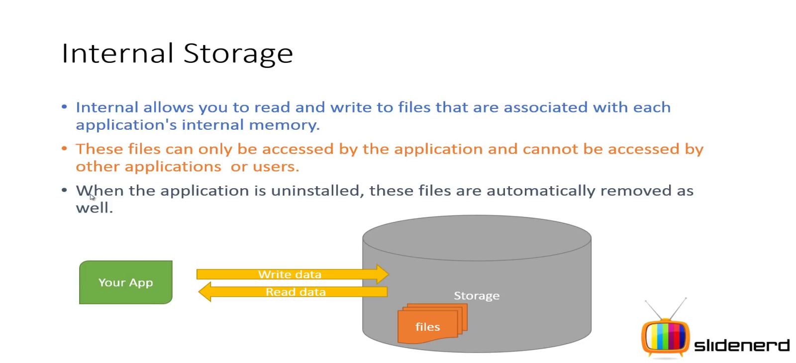

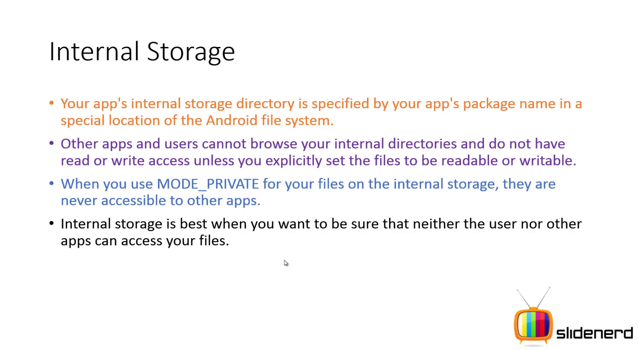

**How to use Internal Storage** :-

We can use Internal Storage –

**To create and write a private file to the internal storage**:

1. Call [openFileOutput(String fileName, int mode)](http://developer.android.com/reference/android/content/Context.html#openFileOutput(java.lang.String, int)) of Activity class with the name of the file and the operating mode. This returns an Object of [FileOutputStream](http://developer.android.com/reference/java/io/FileOutputStream.html) class.

**Q:-What is fileName ?**

**A:-** By this parameter [FileOutputStream](http://developer.android.com/reference/java/io/FileOutputStream.html) creates/updates a file which contains data.

1. Write data in the form of byte[] to the created file by calling [write(byte[])](http://developer.android.com/reference/java/io/OutputStream.html#write(byte[])) on FOS object.
2. Close the stream with [close()](http://developer.android.com/reference/java/io/FileOutputStream.html#close()).

For example:

String FILENAME = "hello_file";  
String string = "hello world!";  
  
FileOutputStream fos = openFileOutput(FILENAME, Context.MODE_PRIVATE);  
fos.write(string.getBytes());  
fos.close();

**How to find where is this saved data located:-**

Click on DDMS->FileExplorer ->data->data-> packageName ->files->FileName

Note:- we can’t see this file in Rooted Physical devices.

**To read a file from internal storage :**

1. Creates an object of StringBuffer (or any other Storage object ) class to store retrieved textual data.
2. Call [openFileInput(String fileName)](http://developer.android.com/reference/android/content/Context.html#openFileInput(java.lang.String)) of Activity class and pass it the name of the file to be read. This returns an object of [FileInputStream](http://developer.android.com/reference/java/io/FileInputStream.html).
3. Read data form [FileInputStream](http://developer.android.com/reference/java/io/FileInputStream.html) object by calling read().
4. Write code to store retrieved data like in StringBuffer Object.
5. Then close the stream with [close()](http://developer.android.com/reference/java/io/FileInputStream.html#close()).

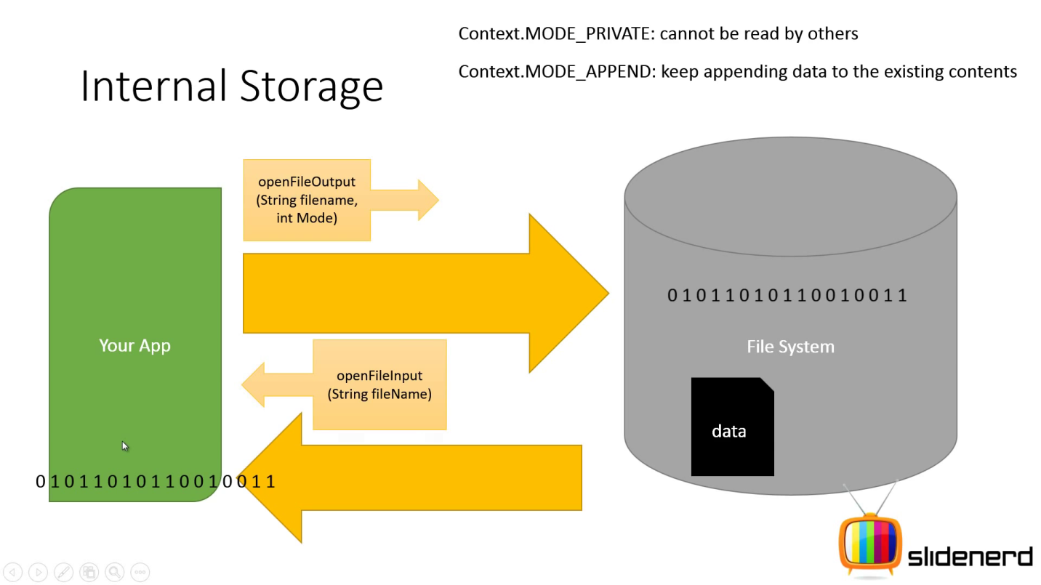

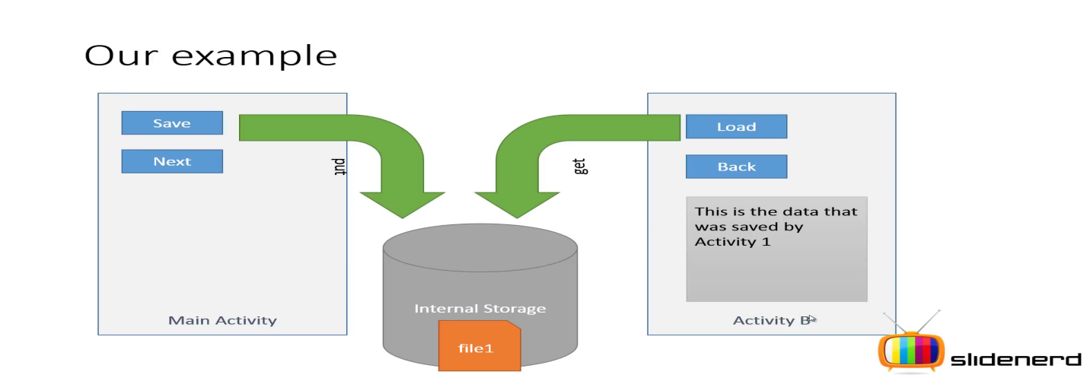

## Using the External Storage :-

Every Android-compatible device supports a shared "external storage" that you can use to save files. This can be a removable storage media (such as an SD card) or an internal (non-removable) storage. Files saved to the external storage are world-readable and can be modified by the user when they enable USB mass storage to transfer files on a computer.

Note:- External storage can be provided by physical media (such as an SD card), or by exposing a portion of internal storage through an emulation layer.

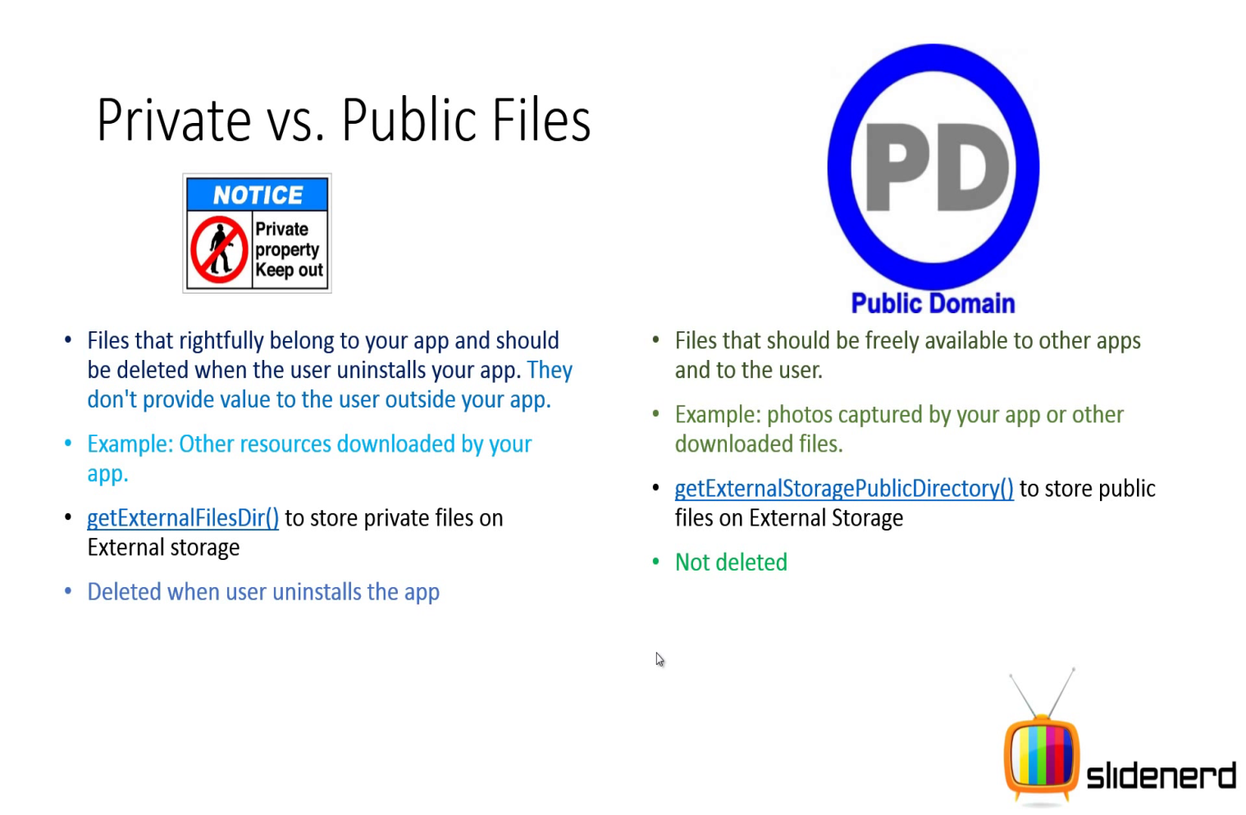

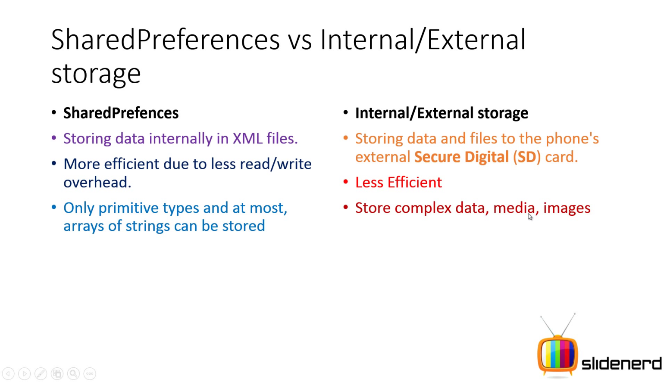

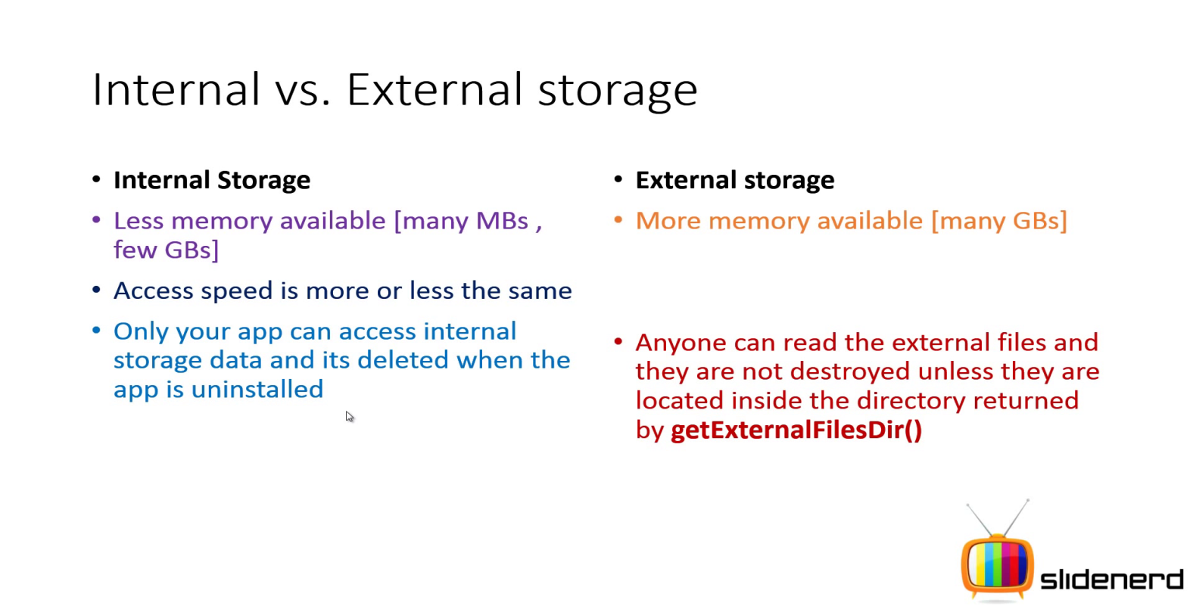

**Caution:** External storage can become unavailable if the user removes the media, and there's no security enforced upon files you save to the external storage. All applications can read and write files placed on the external storage and the user can remove them.

**Note:** We can store public and private both type of data in External Storage. But Recommendation is to put private data/file in Internal Storage and public and big data/files in External Storage.

### Getting access to external storage :-

In order to read or write files on the external storage, your app must acquire the [READ_EXTERNAL_STORAGE](http://developer.android.com/reference/android/Manifest.permission.html#READ_EXTERNAL_STORAGE) or [WRITE_EXTERNAL_STORAGE](http://developer.android.com/reference/android/Manifest.permission.html#WRITE_EXTERNAL_STORAGE) system permissions. For example:

<manifest ...>  
    <uses-permission android:name="android.permission.WRITE_EXTERNAL_STORAGE" />  
    ...  
</manifest>

If you need to both read and write files, then you need to request only the [WRITE_EXTERNAL_STORAGE](http://developer.android.com/reference/android/Manifest.permission.html#WRITE_EXTERNAL_STORAGE) permission, because it implicitly requires read access as well.

**Note:** Beginning with Android 4.4, these permissions are not required if you're reading or writing only files that are private to your app.

### C:\Users\Mokib Khan\Pictures\vlcsnap-2015-05-14-17h04m10s123.jpg

### Checking media availability

Before you do any work with the external storage, you should always call [getExternalStorageState()](http://developer.android.com/reference/android/os/Environment.html#getExternalStorageState())  of Environment class to check whether the media is available. The media might be mounted to a computer, missing, read-only, or in some other state. For example, here are a couple methods you can use to check the availability:

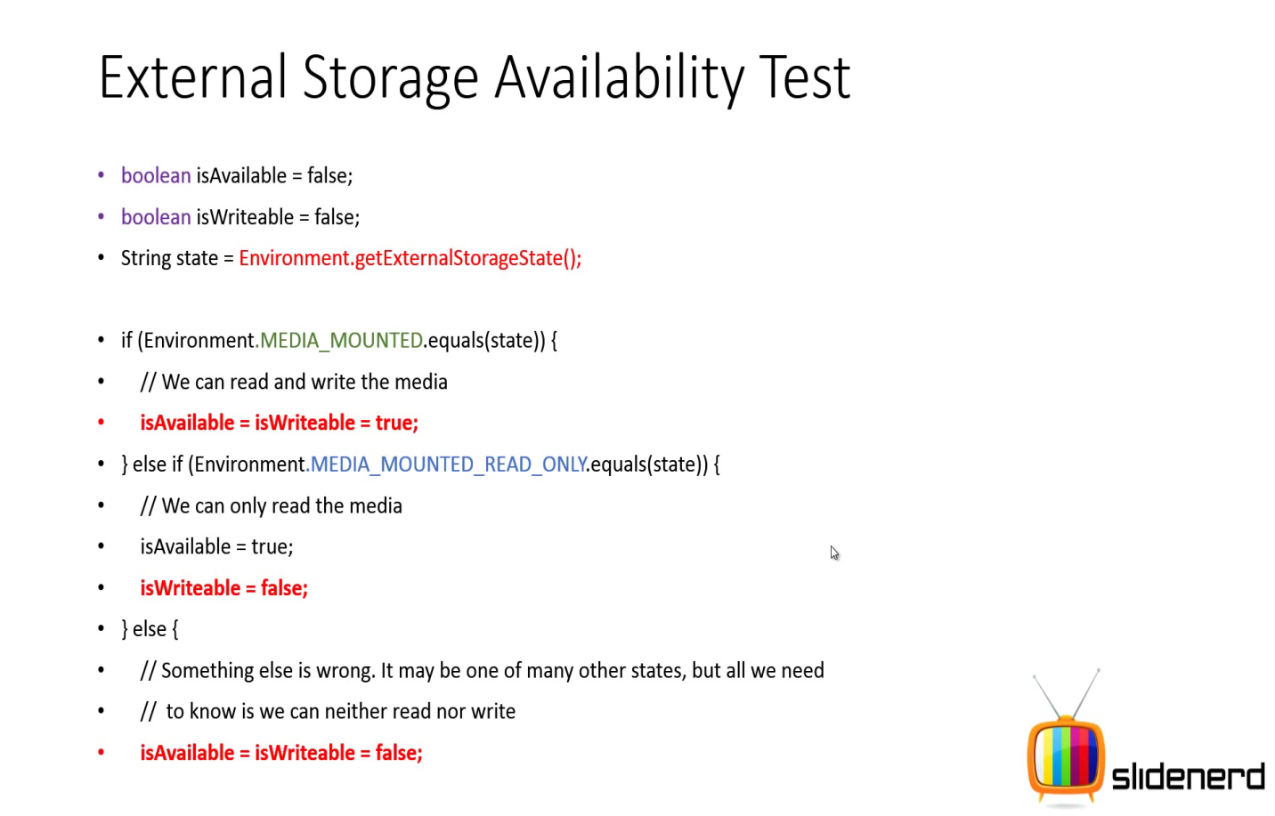

The [getExternalStorageState()](http://developer.android.com/reference/android/os/Environment.html#getExternalStorageState()) method returns other states that you might want to check, such as whether the media is being shared (connected to a computer), is missing entirely, has been removed badly, etc. You can use these to notify the user with more information when your application needs to access the media.

### Saving files (Public data) that can be shared with other apps :-

Generally, new files that the user may acquire through your app should be saved to a "public" location on the device where other apps can access them and the user can easily copy them from the device. When doing so, we should use to one of the shared public directories, such as Music/, Pictures/, and Ringtones/.

To get a [File](http://developer.android.com/reference/java/io/File.html) representing the appropriate public directory, call [getExternalStoragePublicDirectory()](http://developer.android.com/reference/android/os/Environment.html#getExternalStoragePublicDirectory(java.lang.String)), passing it the type of directory you want, such as [DIRECTORY_MUSIC](http://developer.android.com/reference/android/os/Environment.html#DIRECTORY_MUSIC),[DIRECTORY_PICTURES](http://developer.android.com/reference/android/os/Environment.html#DIRECTORY_PICTURES), [DIRECTORY_RINGTONES](http://developer.android.com/reference/android/os/Environment.html#DIRECTORY_RINGTONES), or others. By saving your files to the corresponding media-type directory, the system's media scanner can properly categorize your files in the system (for instance, ringtones appear in system settings as ringtones, not as music).

Note :- we can also pass custom type (any folder name), OS will create directory first then store data.

### C:\Users\Mokib Khan\Pictures\vlcsnap-2015-05-14-22h38m00s204.jpg

### Saving files that are app-private (Private Data) :-

If you are handling files that are not intended for other apps to use (such as graphic textures or sound effects used by only your app), you should use a private storage directory on the external storage by calling [getExternalFilesDir()](http://developer.android.com/reference/android/content/Context.html#getExternalFilesDir(java.lang.String)). This method also takes a type argument to specify the type of subdirectory (such as [DIRECTORY_MOVIES](http://developer.android.com/reference/android/os/Environment.html#DIRECTORY_MOVIES)). If you don't need a specific media directory, pass null to receive the root directory of your app's private directory.

**Note:** When the user uninstalls your application, this directory and all its contents are deleted. Also, the system media scanner does not read files in these directories, so they are not accessible from the [MediaStore](http://developer.android.com/reference/android/provider/MediaStore.html) content provider. As such, you **should not use these directories** for media that ultimately belongs to the user, such as photos captured or edited with your app, or music the user has purchased with your app—those files should be [saved in the public directories](http://developer.android.com/guide/topics/data/data-storage.html#SavingSharedFiles).

Sometimes, a device that has allocated a partition of the internal memory for use as the external storage may also offer an SD card slot. When such a device is running Android 4.3 and lower, the [getExternalFilesDir()](http://developer.android.com/reference/android/content/Context.html#getExternalFilesDir(java.lang.String)) method provides access to only the internal partition and your app cannot read or write to the SD card. Beginning with Android 4.4, however, you can access both locations by calling [getExternalFilesDirs()](http://developer.android.com/reference/android/content/Context.html#getExternalFilesDirs(java.lang.String)), which returns a [File](http://developer.android.com/reference/java/io/File.html) array with entries each location. The first entry in the array is considered the primary external storage and you should use that location unless it's full or unavailable. If you'd like to access both possible locations while also supporting Android 4.3 and lower, use the [support library's](http://developer.android.com/tools/support-library/index.html) static method,[ContextCompat.getExternalFilesDirs()](http://developer.android.com/reference/android/support/v4/content/ContextCompat.html#getExternalFilesDirs(android.content.Context, java.lang.String)). This also returns a [File](http://developer.android.com/reference/java/io/File.html) array, but always includes only one entry on Android 4.3 and lower.

**Caution** Although the directories provided by [getExternalFilesDir()](http://developer.android.com/reference/android/content/Context.html#getExternalFilesDir(java.lang.String)) and [getExternalFilesDirs()](http://developer.android.com/reference/android/content/Context.html#getExternalFilesDirs(java.lang.String)) are not accessible by the [MediaStore](http://developer.android.com/reference/android/provider/MediaStore.html) content provider, other apps with the [READ_EXTERNAL_STORAGE](http://developer.android.com/reference/android/Manifest.permission.html#READ_EXTERNAL_STORAGE) permission can access all files on the external storage, including these. If you need to completely restrict access for your files, you should instead write your files to the [internal storage](http://developer.android.com/guide/topics/data/data-storage.html#filesInternal).

## Using SQLite Databases:-

Android provides full support for [SQLite](http://www.sqlite.org/) databases. Any databases you create will be accessible by name to any class in the application, but not outside the application.

### What is SQLite?

SQLite is an Open Source database. SQLite supports standard relational database features like SQL syntax, transactions and others. The database requires limited memory at runtime (approx. 255 KByte) which makes it a good candidate from being embedded into other runtimes.

SQLite supports the data types TEXT (similar to String in Java), INTEGER (similar to long in Java) and REAL (similar to double in Java). All other types must be converted into one of these fields before getting saved in the database. SQLite itself does not validate if the types written to the columns are not actually of the defined type, e.g. you can write an integer into a string column and vice versa.

### SQLite in Android:-

SQLite is embedded into every Android device. Using SQLite database in Android does not require a setup procedure or administration of the database.

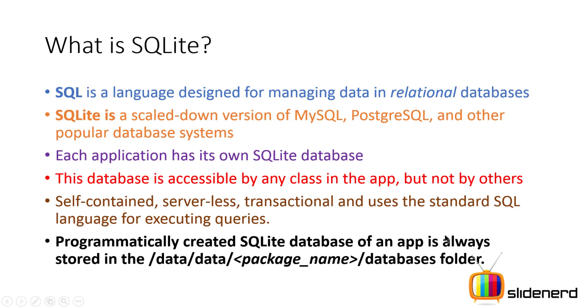

**NOTE:-** The android.database package contains all necessary classes for working with databases. The android.database.sqlite package contains the SQLite specific classes.

### Creating and updating database with SQLiteOpenHelper

To create and upgrade a database in your Android application you create a subclass of the SQLiteOpenHelper class. In the constructor of your subclass you call the super() constructor of SQLiteOpenHelper, specifying the database name and the current database version.

In this class you need to override the following methods to create and update your database.

* **onCreate(SQLiteDatabase db)**
* **onUpgrade(SQLiteDatabase db)**

Both methods receive an SQLiteDatabase object as parameter which is the Java representation (object) of the database.

The SQLiteOpenHelper class also provides following methods to get access to an SQLiteDatabase object; either in read or write mode.

1. SQLiteDatabase **getReadableDatabase()** and
2. SQLiteDatabase **getWriteableDatabase()**

**Note:-** The database tables should use the identifier row_id for the primary key of the table. Several Android functions rely on this standard.

### SQLiteDatabase class:

SQLiteDatabase is the base class for working with a SQLite database in Android and provides methods to open, query, update and close the database.

More specifically SQLiteDatabase provides the insert(), update() and delete() and query() methods.

**Database designing approache:**

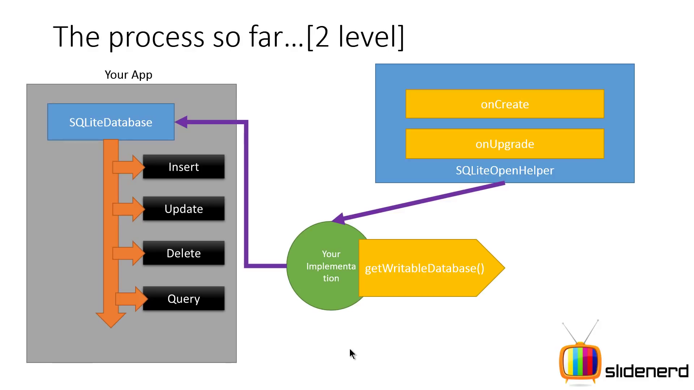

**Steps to create Database :-**

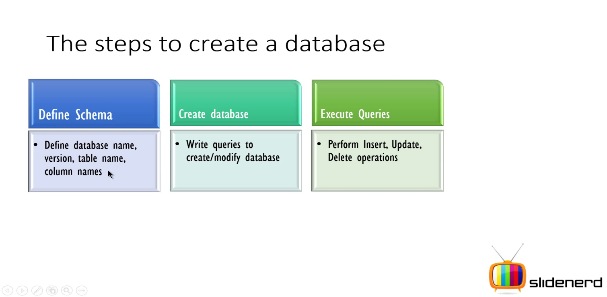

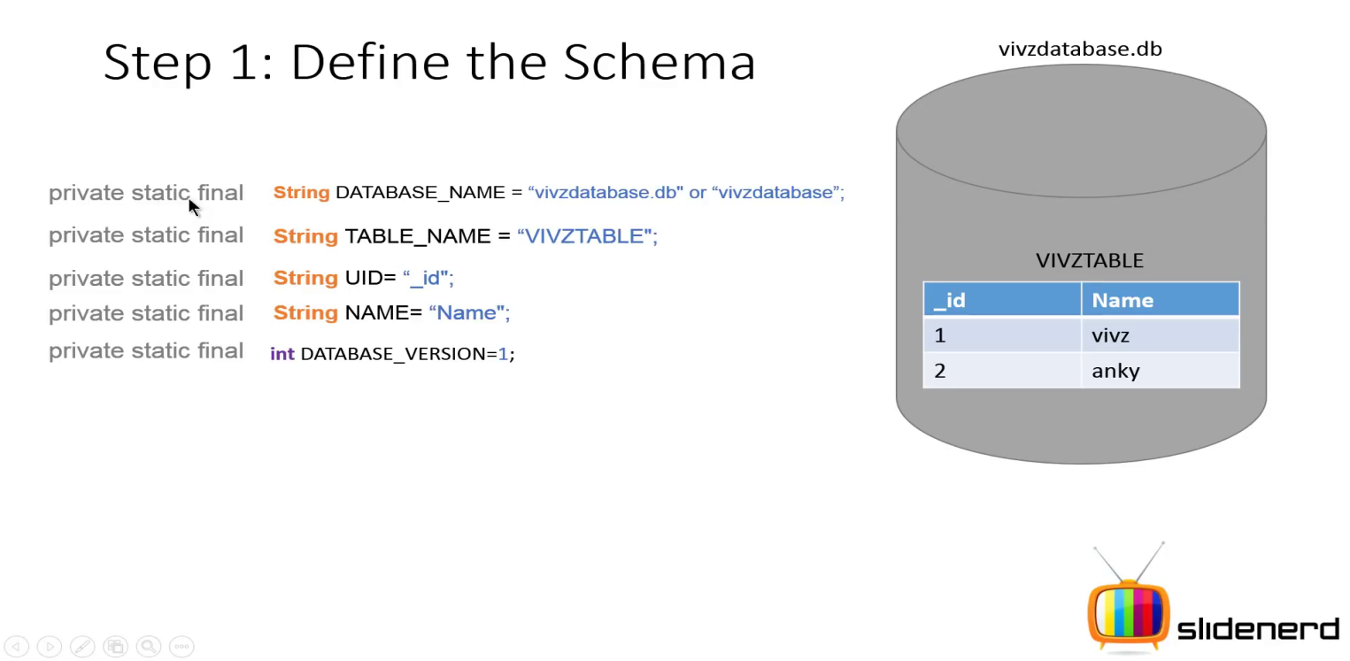 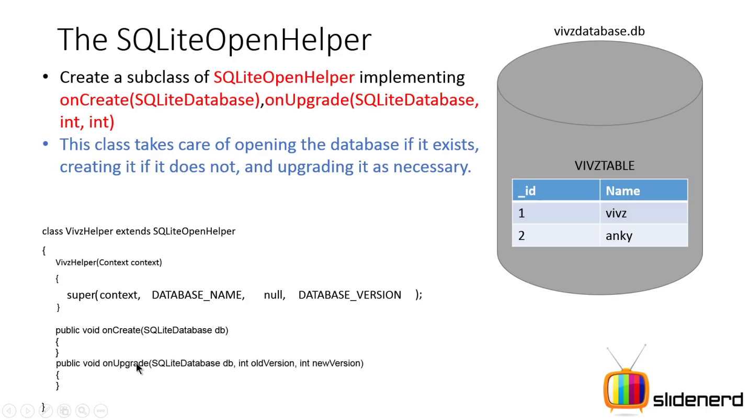 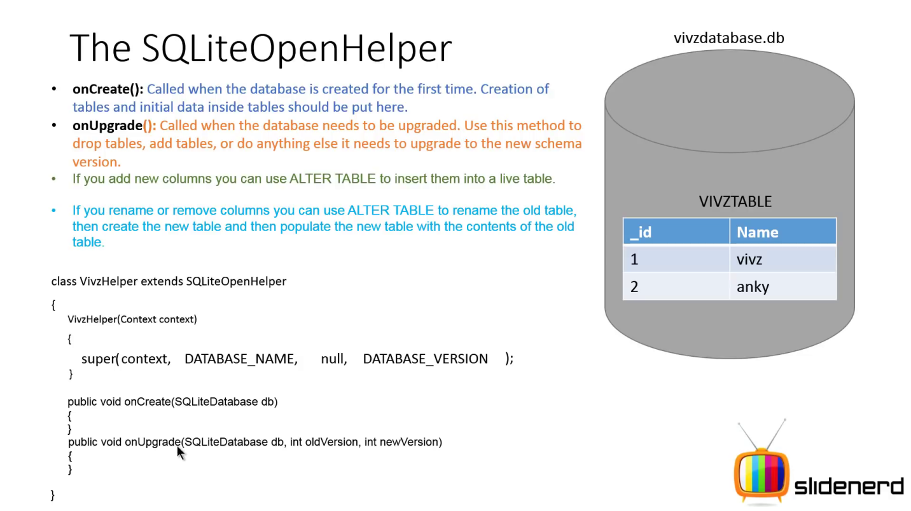 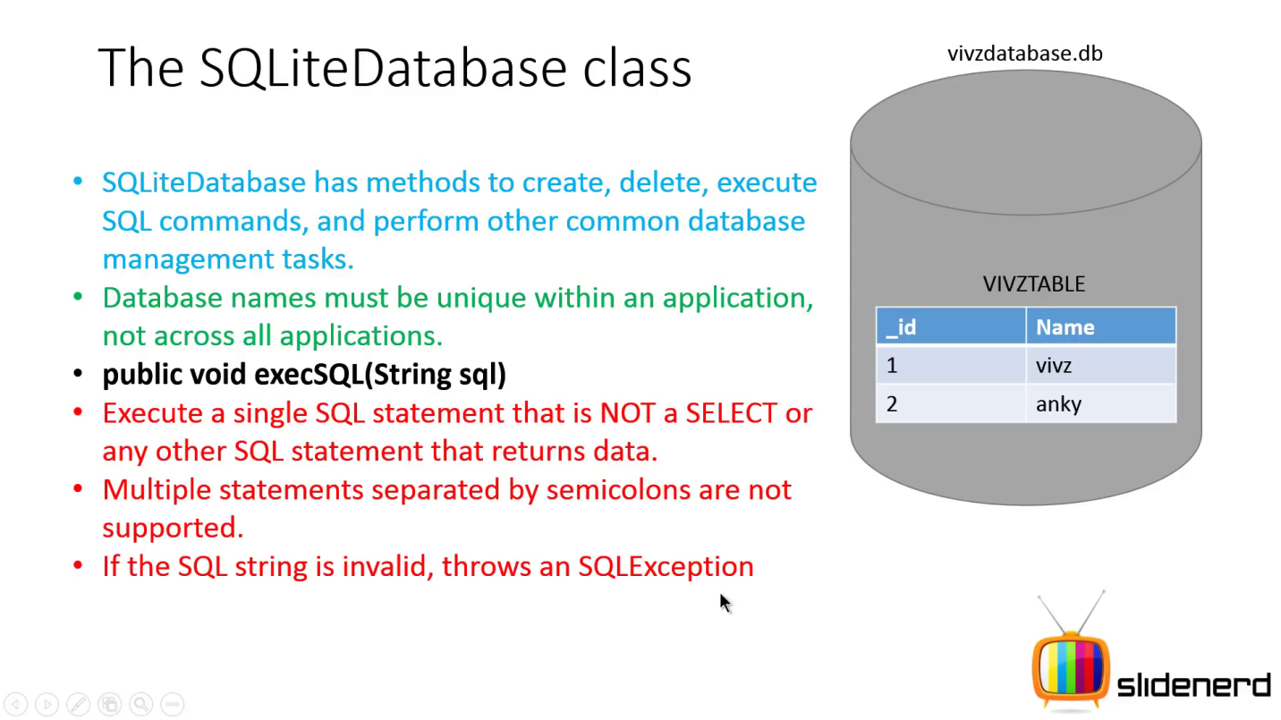 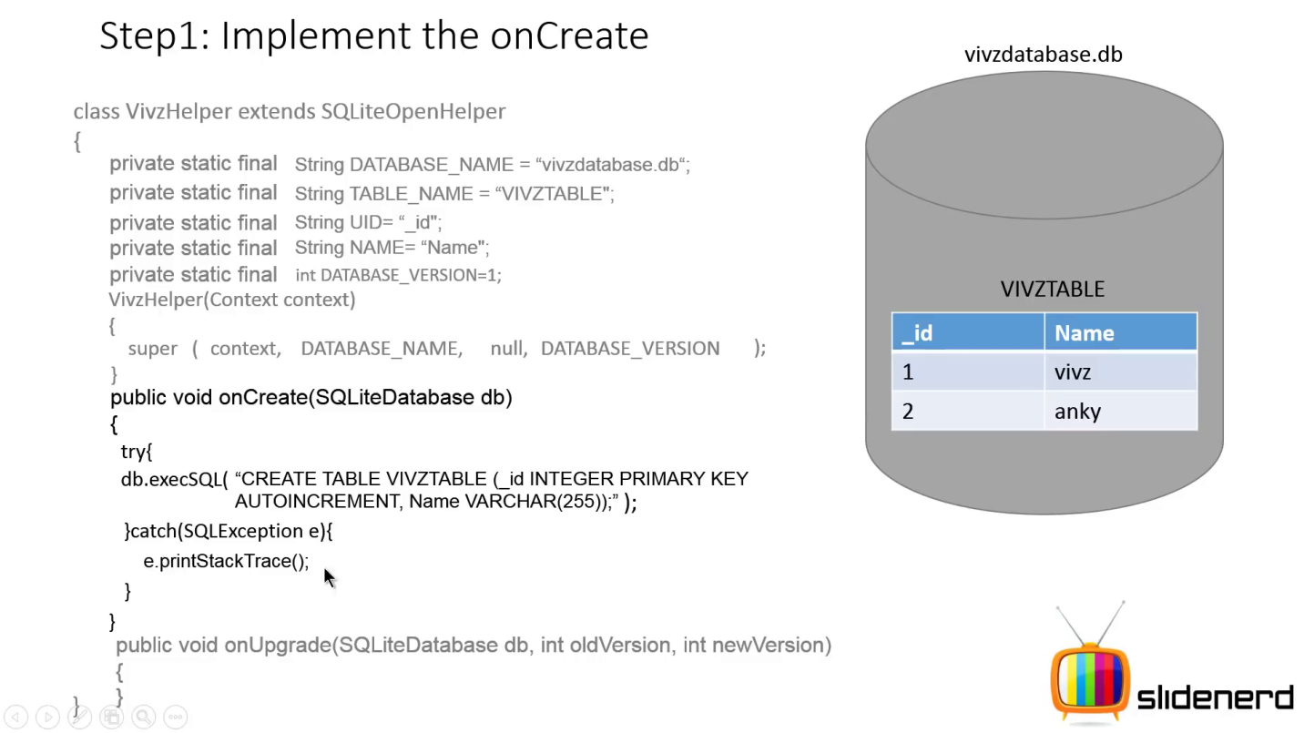 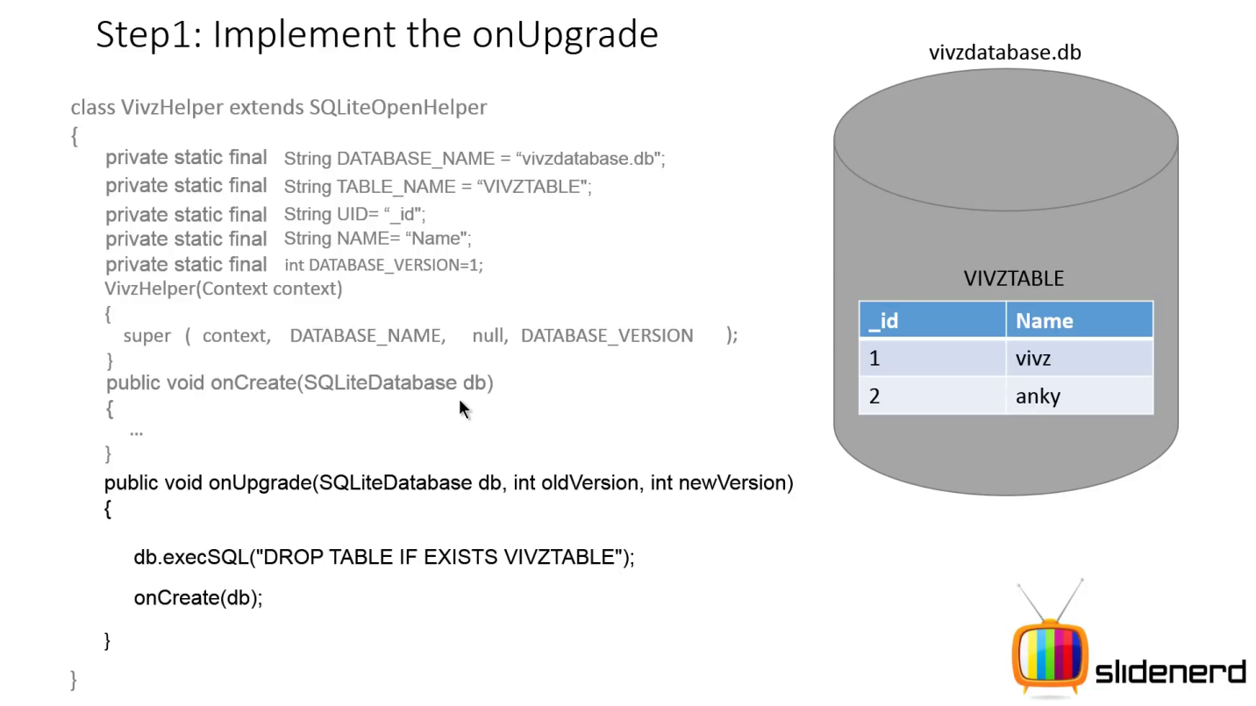

**Data Insertion in Database:** In Android we can do it by following way:-

**Latest way (Android way) of data insertion:**

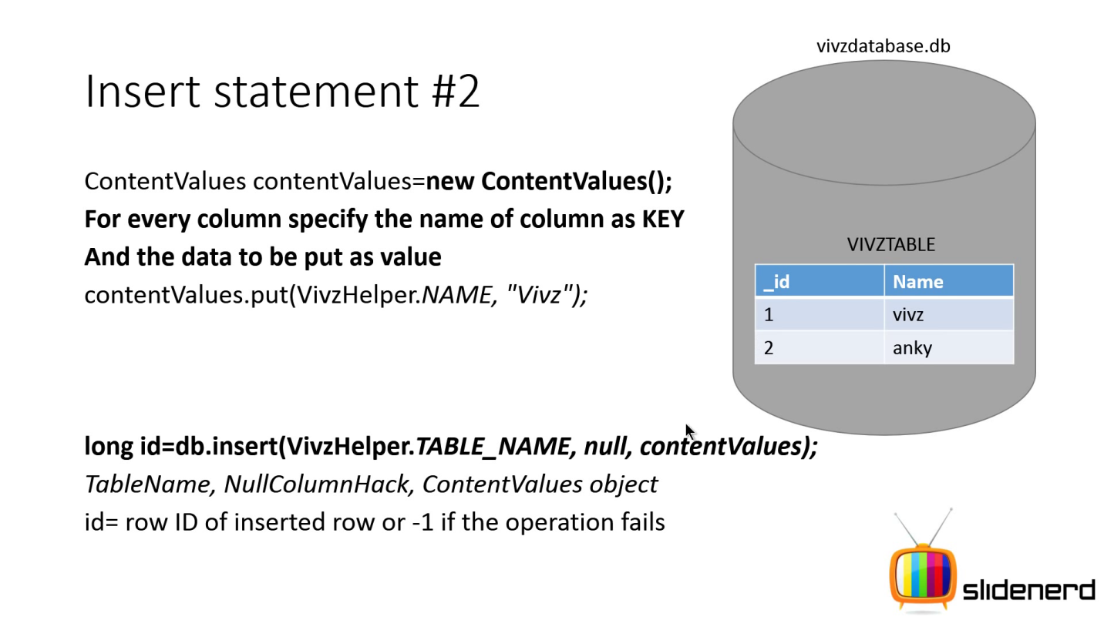

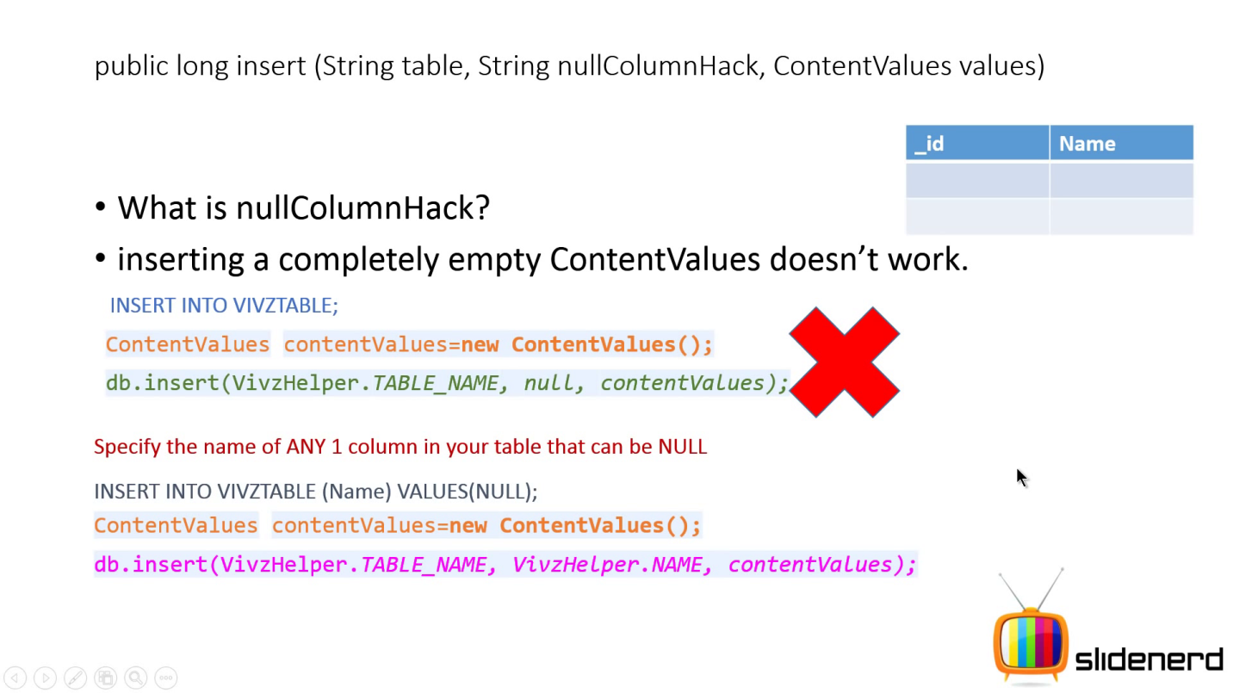 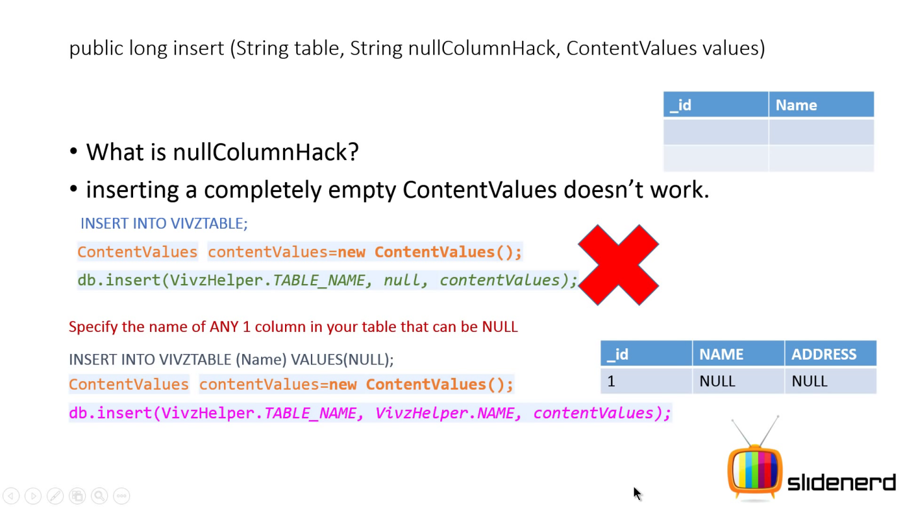

**ContentValues** :- The object of this class allows to define key/values. The *key* represents the table column identifier and the *value* represents the content for the table record in this column.

ContentValues can be used for inserts and updates of database entries.

**How to extract data from Database:** we can do it by following way -

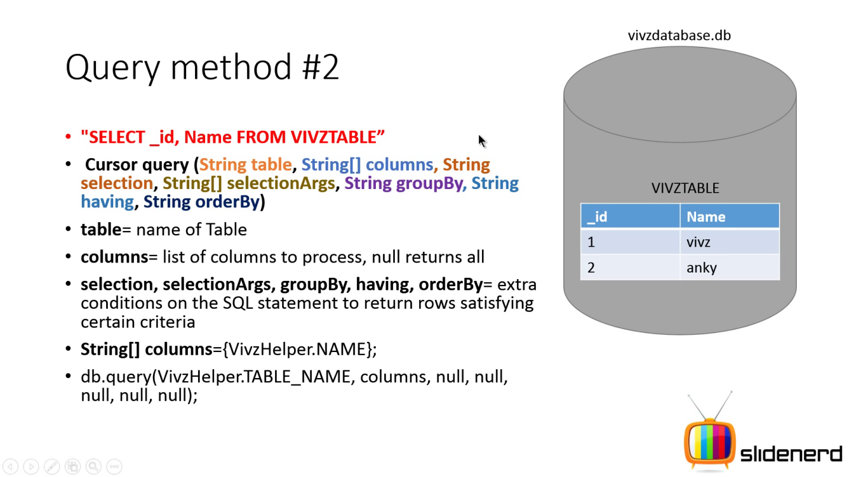

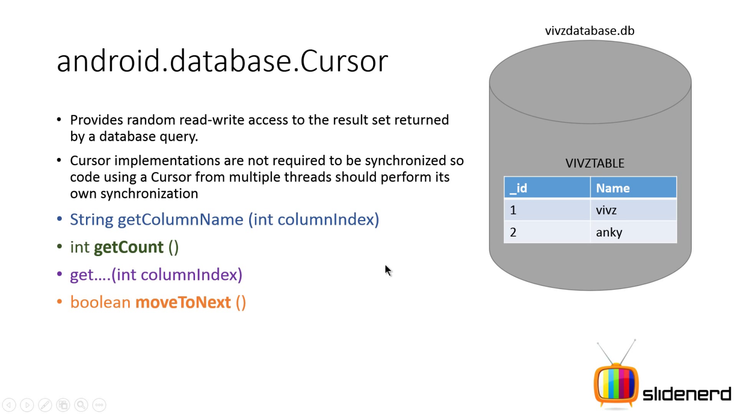

**NOTE:- Column indices start from 0 in Cursor object.**

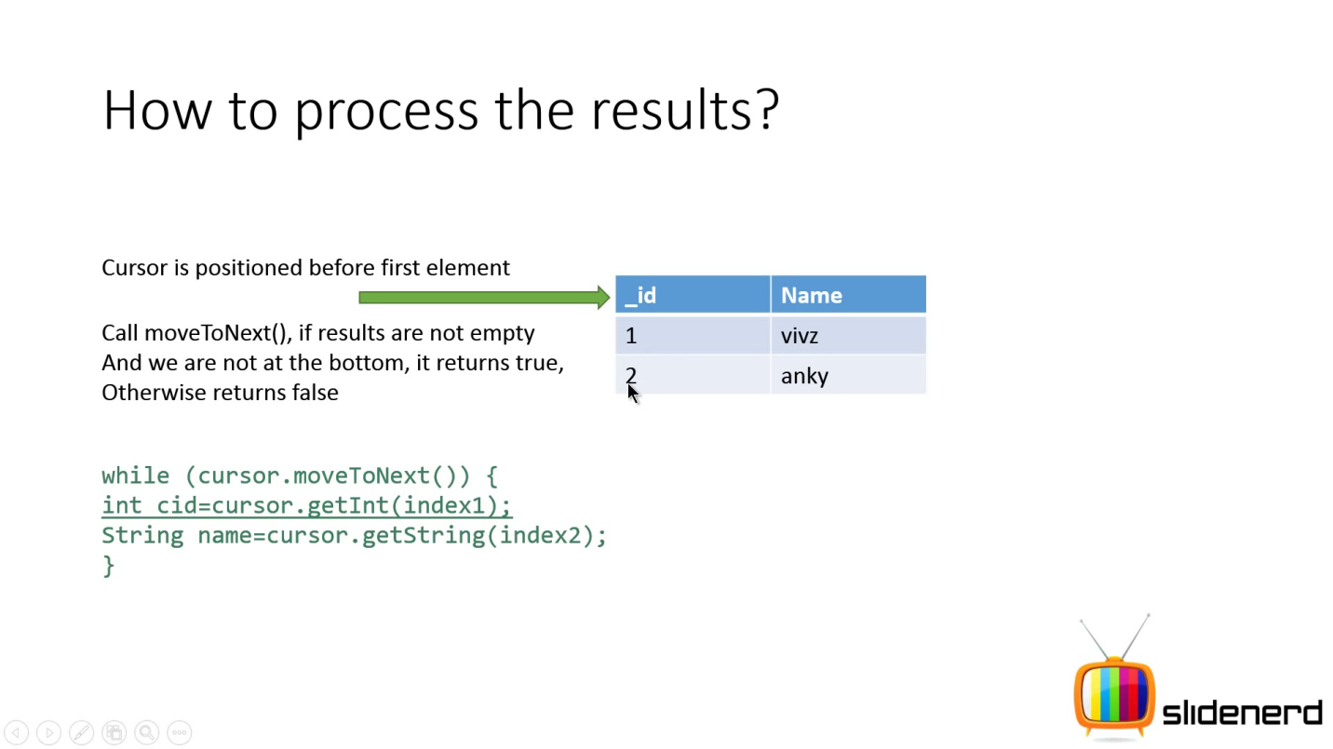

**How to Delete and Update data from Database:** we can do it as follows -

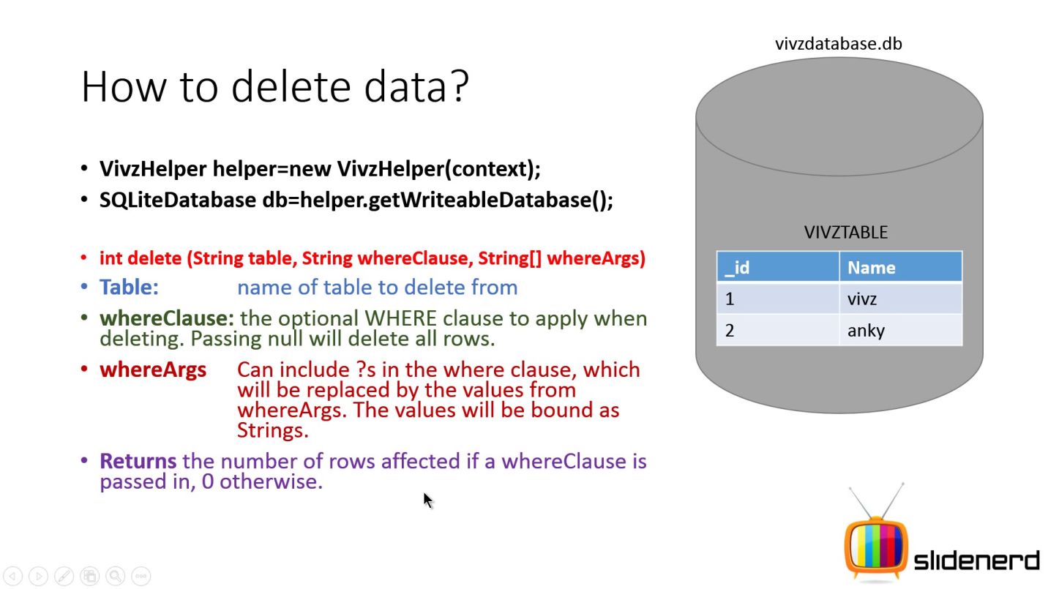

**Example:-**

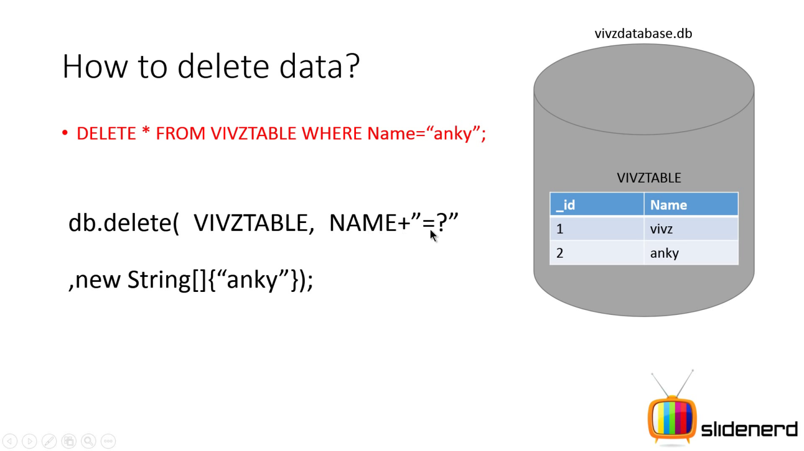

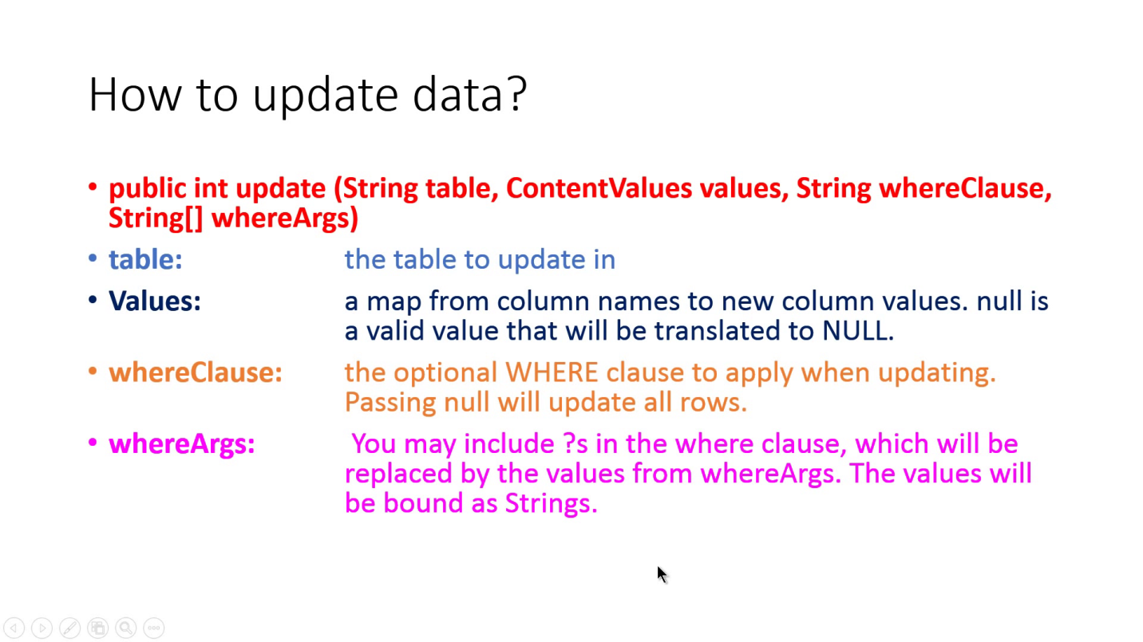

**Example:**

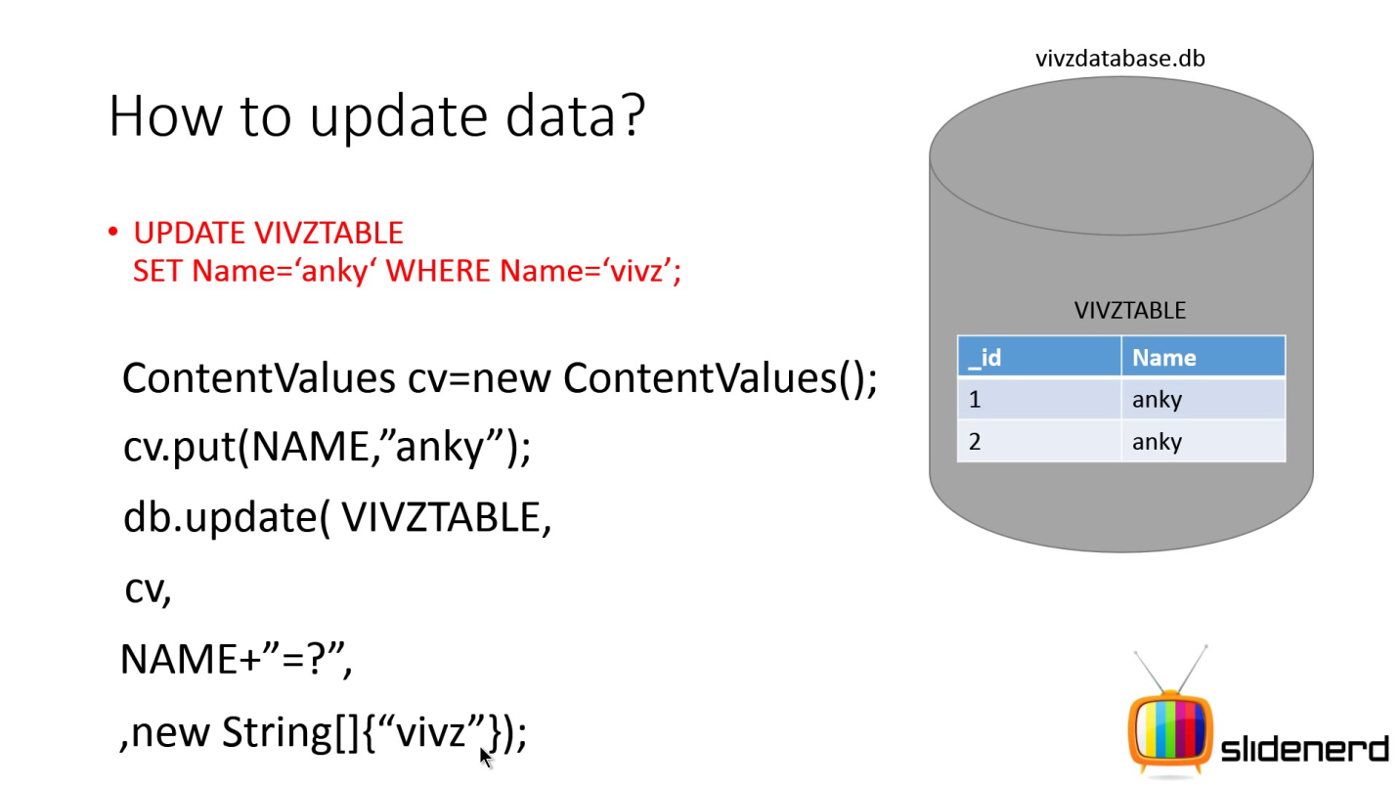

**Using a Network Connection**

You can use the network (when it's available) to store and retrieve data on your own web-based services. To do network operations, use classes in the following packages:

* [java.net.*](http://developer.android.com/reference/java/net/package-summary.html)
* [android.net.*](http://developer.android.com/reference/android/net/package-summary.html)